QUESTION BANK ON 100 YEARS OF CHAMPARAN

- In which state of India is Champaran?

  - Andhra Pradesh
  - Jharkhand
  - Chattisgarh
  - Bihar

- On whose insistence did Gandhiji visit Champaran?

  - J B Kripalani
  - Gopal Krishna Gokhale
  - Raj Kumar Shukla
  - Rajendra Prasad

- In which year did famine strike Champaran, proving the last straw for oppressed indigo farmers?
  - 1914
  - 1915
  - 1916
  - 1917

- In whose house did Gandhiji initially stay in on reaching Patna enroute Champaran?

  - Maulana Mazrahul Haq
  - Rajkumar Shukla
  - Rajendra Prasad
  - Braj kishore Prasad

- Who received Gandhiji at Muzaffarpur Railway Station when he came from Patna?

  - Aacharya Kripalani
  - Srinivas Shashtri
  - CR Das
  - JB Kripalani

- In which year did Gandhiji launch Champaran Satyagraha?

  - 1915
  - 1916
  - 1917
  - 1918

- The Champaran Satyagraha was associated with_______

  - Salt
  - Indigenous textiles
  - Indigo
  - Prevailing land owning system

- Which cultivation system was followed in Champaran?

  - Ryotwari
  - Mahalwari
  - Tinkathia
  - Kurtauli

- As per the record available, in which year was the first indigo disturbance reported in Champaran?
  - 1871
  - 1869
  - 1875
  - 1867

- Whose order did Gandhiji disobey when he continued to stay in Champaran?

  - Lt. Governor
  - District magistrate
  - British Council
  - Lawyer

- What is the name of the exhibition that PM Narendra Modi inaugurated marking 100 years of Satyagraha in Champaran?

  - Bapu ka abhiyan
  - A final end to movement against British Raj
  - Naya Bharat
  - Swachhagraha – Bapu Ko Karyanjali – Ek Abhiyan, Ek Pradarshani

- When did Gandhiji set his foot in Champaran for the first time?

  - April 10, 1917
  - May 9, 1918
  - April 6, 1916
  - None of these

- From where did Gandhiji begin his work after reaching Champaran?

  - House of Babu Gorakh Prasad in Motihari
  - From the land of farmers
  - After Salt March
  - From the office of British Council

- When did the Champaran Inquiry Committee submit its final report?

  - November 6
  - October 4
  - September 10
  - None of these

- When did the Champaran Agrarian Bill converted into a law?

  - November 29, 1919
  - March 4 , 1920
  - March 4, 1919
  - None of these

- When was the word “Satyagraha” first used?

  - Anti- Rowlatt Act agitation
  - Farmers Protection Act
  - When the indigo unrest took place
  - All of these

- Satyagraha at which of the following places was NOT related to the problems of farmers?

  - Ahmedabad
  - Kheda
  - Bardoli
  - Champaran

- Why did Gandhiji decide to go to Muzaffarpur before going to Champaran?

  - To enquire from the lawyers about the issue
  - To seek guidance from his friend
  - To visit his supporters
D) None

- How did Gandhiji make the peasants fearless and self-reliant?

  - By letting them know about their rights
B) Fighting their case
C) Obtaining the refund of compensation
D) All of the above

- What portion of land were the farmers forced to allocate/reserve for indigo cultivation under the cropping system in effect?

  - 1/10
  - ½
  - 3/20
  - None of these

- Why was Gandhiji asked to leave Champaran by the Commissioner?

  - Disruption of public harmony
  - Danger to public tranquillity
  - Violent agitation
  - All of the above

- Name the district magistrate who served Gandhiji the notice to leave Champaran district.

  - W.B. Heycock
  - Allen Dyer
  - Arthur Hermen
  - None of these

- Name the section under violation of which summons was issued to Gandhiji?

  - Section 140
  - Section 144
  - Section 123
  - Section 146

- What stand did Gandhiji assume during his court appearance for defying the Magistrate’s order?

    - He did not appear for the trial
    - He plead guilty
    - He did not consider the order to have legitimate authority
    - Both A and C

- Which railway station in Bihar was renamed Bapu Dham after Gandhiji, a few years ago?

- Patna
- Champaran
- Motihari
- Muzaffarpur

- Why did indigo exports from India decline, adding to the misery of the Champaran farmers?

    - Due to development of a synthetic dye
    - Because of the Opium War with China affecting trade routes
    - High export tariffs imposed by the Crown
    - All of the above

- On what date did Gandhiji land in Motihari?

  - May 9, 1917
  - April 2, 1917
  - April 15, 1917
  - May 16, 1917

- In which session of the Indian National Congress did Gandhiji meet Raj Kumar Shukla?

  - 29
  - 30
  - 32
  - 31

- Where was the Congress session held, where Gandhiji first met Raj Kumar Shukla?

  - Patna
  - Lucknow
  - Poona
  - Allahabad

- What deal did the District Magistrate offer Gandhiji to drop the case against him?

  - To leave the district and not return
  - To head the enquiry committee
  - To assist the Bihar Planters Association in restructuring the cropping system
  - None of the above

- Who was the secretary of the Indigo Planters Association whom Gandhjii met to explain his mission?

  - Mr. Morshead
  - Mr.Wilson
  - Mr.Maude
  - Mr.Louis

- In which town/city did Gandhiji reside?
  - Patna
  - Motihari
  - Bhagalpur
  - Bettiah

- In which three places did Gandhiji lay the foundation for schools in Champaran in 1917-18?

  - Motihari, Patna, Ranchi
  - Bhagalpur, Bettiah, Jasaulipatti
  - Bhitiharwa, Motihari, Madhuban
  - Madhuban, Patna, Muzaffarpur

- What was the name of the self sustaining vocational schools that Gandhiji set up in Bihar to provide training in carpentry, weaving and the like called?

  - Buniyadi Schools
  - Karigari Schools
  - Kaushalya Schools
  - None of the above

- What was the Bhitiharwa Ashram in Champaran originally known as?

  - Gandhi Ashram
  - Champaran Seva Gram
  - Sabarmati Ashram
  - Kasturba Sewa Kendra

- Under the jurisdiction of which revenue division did Champaran fall in Bihar?

  - Tirhut
  - Darbhanga
  - Bhagalpur
  - Saran

- Who was the Lt. Governor of Bihar & Orissa during the Champaran Satyagraha?

  - L.F Morshead
  - Sir Edward Gait
  - G.S. Arndale
  - E.S. Montague

- How did Gandhiji initiate the satyagraha movement in Champaran?

  - By convincing the oppressed peasants to refuse to pay the taxes
  - By recording their grievances
  - By seeking a meeting with Lt. Governor Edward Gait to negotiate better terms for the peasants
  - A and B both

- On whom did the British Government bestow the title of Kaiser-i-Hind?

    - Jawaharlal Nehru
    - Sardar Vallabhai Patel
    - Braj kishore Prasad
    - Mahatma Gandhi

- Which medal did Gandhiji wish to return, in a letter he wrote to Maganlal Gandhi, in protest of the treatment meted out to peasants in Champaran?

    - Bharath-Kesari
    - Daiser-i-Hind
    - Kaiser-i-Hind
    - None of the above

- For the centenary celebrations of Champaran Satyagraha, an online interactive quiz was organised by

    - ASI
    - National Archives of India
    - Ministry of Culture
    - Indian National Trust for Art and Cultural Heritage

- Hon’ble Prime Minister, while inaugurating the 100-year celebrations of Champaran Satyagraha, appealed to the citizens of India to replicate its success for

    - Make in India
    - Digital India
    - Swach Bharat
    - KaushalVikas

- The Champaran Inquiry Committee submitted its final report to the British Government on…?

    - October 1st, 1917
    - October 4th, 1917
    - October 5th, 1917
    - October 7th, 1917

- What was the principal recommendation of the report submitted by the Champaran Inquiry Committee, accepted by the Government?

- Abolition of mandatory indigo cultivation
- Revision and lowering of taxes imposed on the peasants
- Abolition of bear labour system
- Abolition of the Tinkathia system

- What did Gandhjii call the debacle of the collapsed Motihari trial against him?

    - “…(India’s) first lesson in Civil Disobedience.”
    - “…the beginning of Ahimsawad”
    - “The first brush of the Crown with the ultimate power of satya and ahimsa.”
    - None of the above

- When was the Champaran Agrarian bill turned into a law?
    - March 4, 1920
    - March 7, 1919
    - May 2, 1917
    - None of the above

- After the Champaran Satyagraha, where did Gandhiji go next?
    - Kheda
    - Chauri Chaura
    - Ahmedabad
    - Yervada

- By what percentage did Gandhiji finally succeed in reducing the rent of the land, after much negotiation?
    - 40 %
    - 26%
    - 25%
    - 30%

- Raj Kumar Shukla’s diary, in which he assiduously recorded the events of Champaran Satyagraha, was written in which of the following script?

  - Kaithi
  - Maithli
  - Bhojpuri
  - Devnagiri

- What was the name of the book released by Bihar CM Nitish Kumar, on the 10th of April, commemorating hundred years of Champaran agitation?

  - Bharat ka Poorna Satyagraha
  - Champaran: Satyagrah ke Sahyogi
  - Champaran: Ek Nil Vidroh
  - None of the above

- Where was the first school founded by Gandhiji, in Champaran, located?

  - Bhitiharwa
  - Motihari
  - Madhuban
  - Jasaulipatti

- Who is the author of the book on Raj Kumar Shukla and others involved in the Champaran movement, released on April 10th 2017, while celebrating 100 years of the Satyagraha?

  - Anurag Narayan Sinha
  - Pir Mohammad Munis
  - B.L Das
  - Arvind Mohan

- Who translated the contents of Raj Kumar Shukla’s diary into Hindi and released it as a book?

  - Krishanb Dutt
  - Bhairav Lal Das
  - A.C Ammon
  - Sheikh Rajab Ali

- Though Champaran is widely acknowledged as the first Satyagraha movement launched in India, when was the word Satyagraha actually used for the first time?

    - Anti-Rowlatt Act Agitation
    - Ahmedabad Mill-workers strike
    - Khilafat Movement
    - Simon Commission protests

- Who, in a book about Gandhiji, famously wrote of Champaran’s enforced indigo plantations saying, “Not a chest of Indigo reached England without being stained with human blood.”?

  - Charles F. Andrews
  - Subhadra Sen Gupta
  - Louis Fischer
  - D.G Tendulkar

- Besides Raj Kumar Shukla, who were the other two members of the delegation that went to meet Gandhiji at the Indian National Congress session in 1916?

  - Ganesh Shankar Vidyarthi and Pundit Sundarlal
  - HaribansSahay and Pir Mohammad Munis
  - Pundit Sundarlal and Mohammad Ansari
  - Mohammad Ansari and Ganesh Shankar Vidyarthi

- According to a number of historians, who might have actually composed the letters written to Gandhiji apprising him of Champaran’s situation, in Shukla’s name?

  - Ganesh Shankar Vidyarthi
  - Pir Mohammad Munis
  - Banarsidas Chaturvedi
  - Haribans Sahay

- Who launched the book ‘Gandhi in Champaran’ in New Delhi, in April 2017, as a part of 100 years of Champaran celebrations?

  - Narendra Modi
B) Venkaiah Naidu
C) Mahesh Sharma
- Nitish Kumar

- Where was Gandhiji headed when he was stopped and ordered to leave the district immediately?

  - Motihari
  - To the Commissioner of Tirhut
  - Jasaulipatti
  - Muzaffarpur
- Who is the author of the book “Gandhi in Champaran”?

  - Shankar Dayal Singh
  - D.G Tendulkar
  - Subhadra Sen Gupta
  - None of the above

- The Champaran Enquiry Committee had ______ members?

  - Six
  - Three
  - Seven
  - Five

- When was the book “ Satyagraha in Champaran”, written by Rajendra Prasad, first published?

  - 1922
  - 1930
  - 1927
  - 1934

- Before Champaran, where did a famous indigo revolution take place?

  - Bardoli
  - Rajmahal Hills
  - Santhal
  - Bengal

- In which session of the Indian National Congress did Raj Kumar Shukla and others attend, to persuade Gandhiji to take up their cause?

  - Twenty-ninth
  - Thirtieth
  - Thirty-first
  - Thirty-fifth

- Who was the Secretary of the Planters’ Association in Champaran?

  - H.S Polak
  - W.B Heycock
  - D. Weston
  - J.M Wilson

- Which biographer of Gandhiji accompanied him in Champaran?

  - Charles F. Andrews
  - Joseph L. Roils
  - Louis Fischer
  - None of his biographers were present in Champaran

- Gandhiji and his aides stayed in the house of………………?

  - Rajendra Prasad
  - Anurag Narayan Sinha
  - Gorakh Prasad
  - MazhrahulHaq

- Out of the various places Gandhiji resided in during his stay in Champaran, which place did CM Nitish Kumar announce would be turned into a museum?

  - Gorakh Prasad’s house
  - Brajkishore Prasad’s house
  - Bettiaha Dharamshala
  - Rajendra Prasad’s house

- Who was the President of the Champaran Enquiry Committee?

  - F.G Slay
  - D.J Reid
  - G. Rainy
  - L.C Adami

Multimedia Questions:

- Identify Raj Kumar Shukla from the personalities below

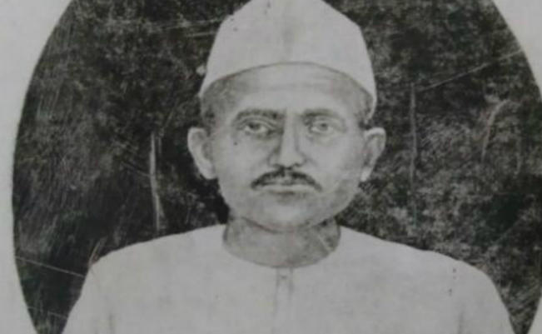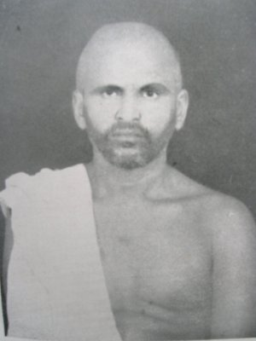

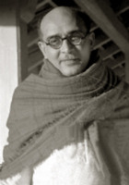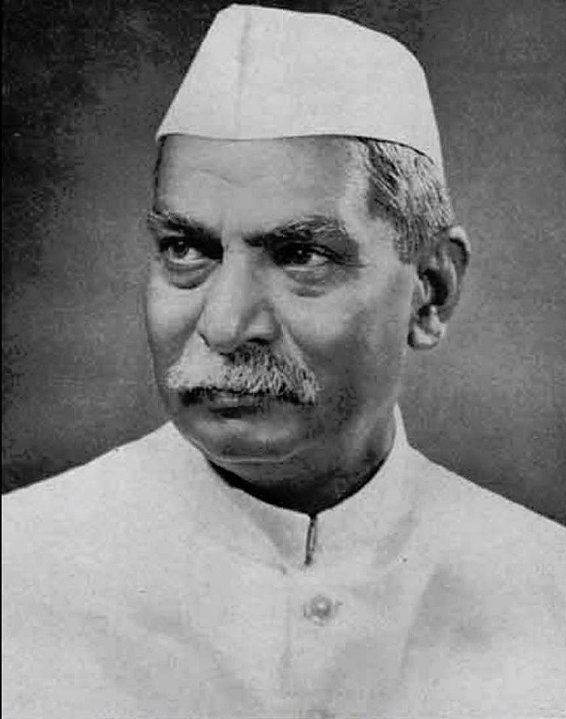

- On a map of India, mark the state that Champaran falls in

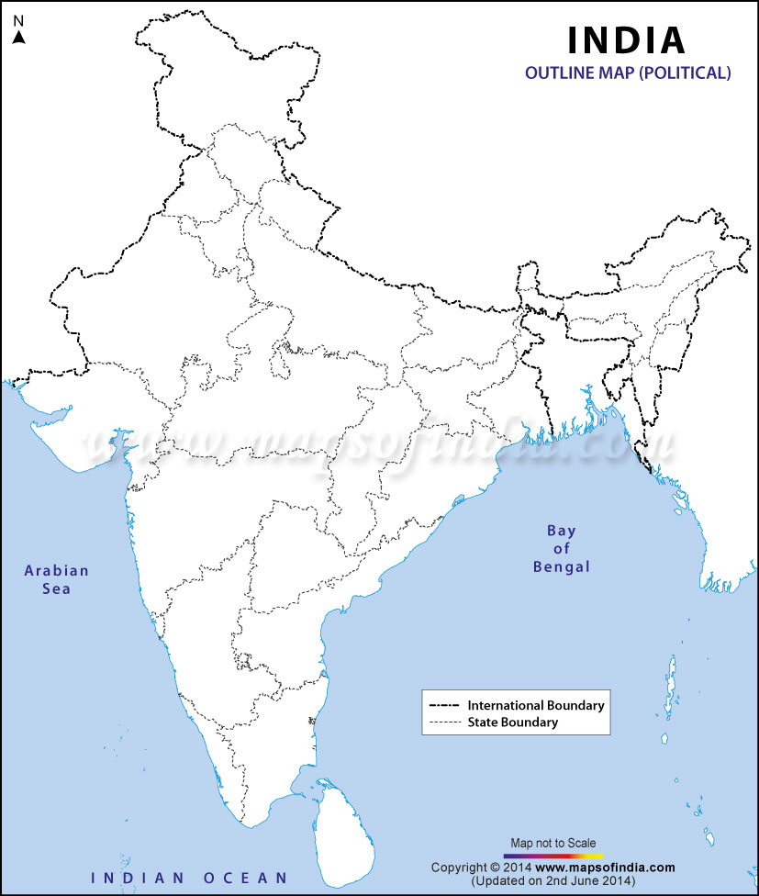

- Which biographer of Gandhi ji accompanied him in Champaran?

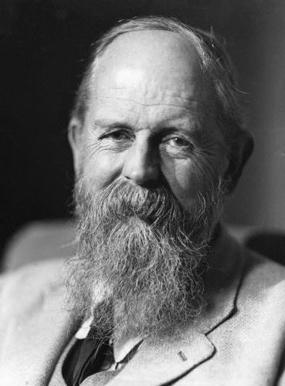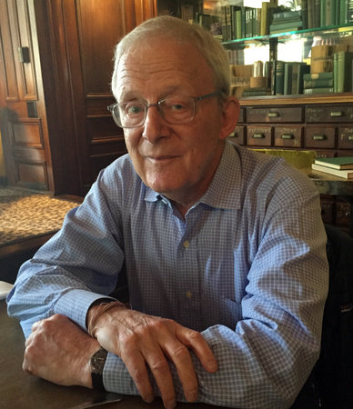

A) Charles F. Andrew B) Joseph L. Roils

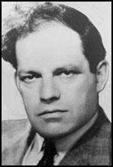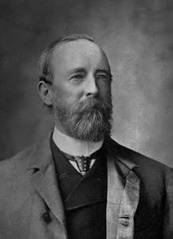

C) Louis Fischer D) A.O Hume

